RoomCompanion
System Design Write-up

RoomCompanion connects tenants looking for accommodation with owners posting room listings. The system ranks listings by a compatibility score, gates communication behind an explicit acceptance step, and uses production-oriented services for scoring, messaging, and notifications. This document covers four core subsystems — compatibility scoring, LLM integration and fallback, real-time chat, and notification flow — followed by cross-cutting concerns, with diagrams and reference tables throughout.

System Architecture Overview
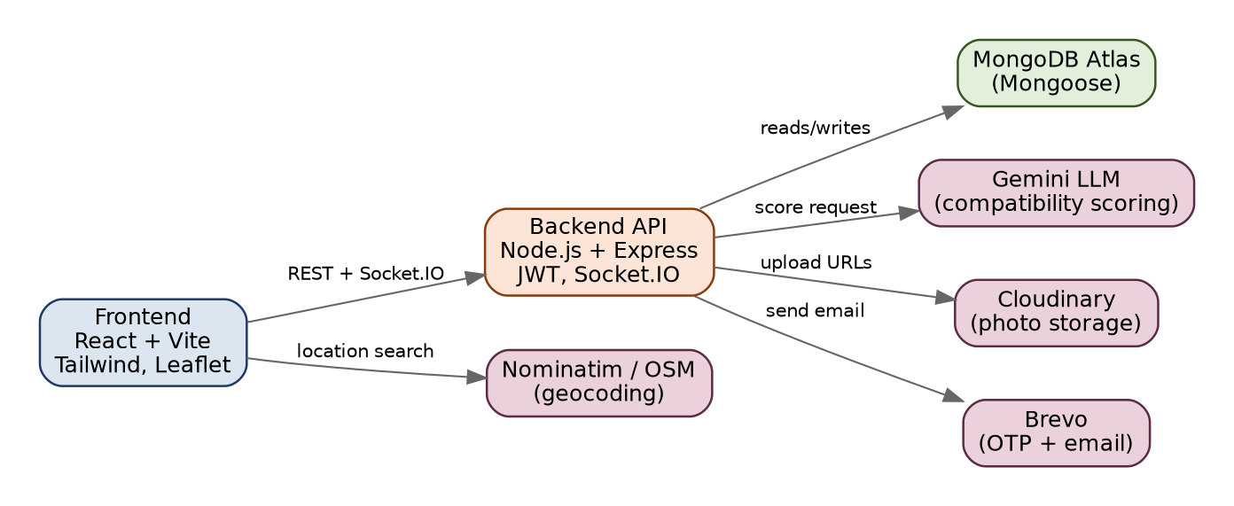
Figure 1 — High-level architecture: client, API layer, database, and external services.
Layer | Technology | Responsibility
Frontend | React + Vite, Tailwind CSS, Leaflet | UI, listing search/filter, map-based location picking
Backend | Node.js, Express.js, Socket.IO | REST API, auth, business logic, real-time messaging
Database | MongoDB Atlas + Mongoose | Persistent storage for all domain entities
AI Scoring | Gemini LLM | Compatibility score + explanation generation
Media | Cloudinary | Room photo upload and delivery
Email | Brevo | OTP verification and transactional notifications
Location | Nominatim / OpenStreetMap | Location search and reverse geocoding
Table 1 — Technology stack by layer and responsibility.

End-to-End User Flow
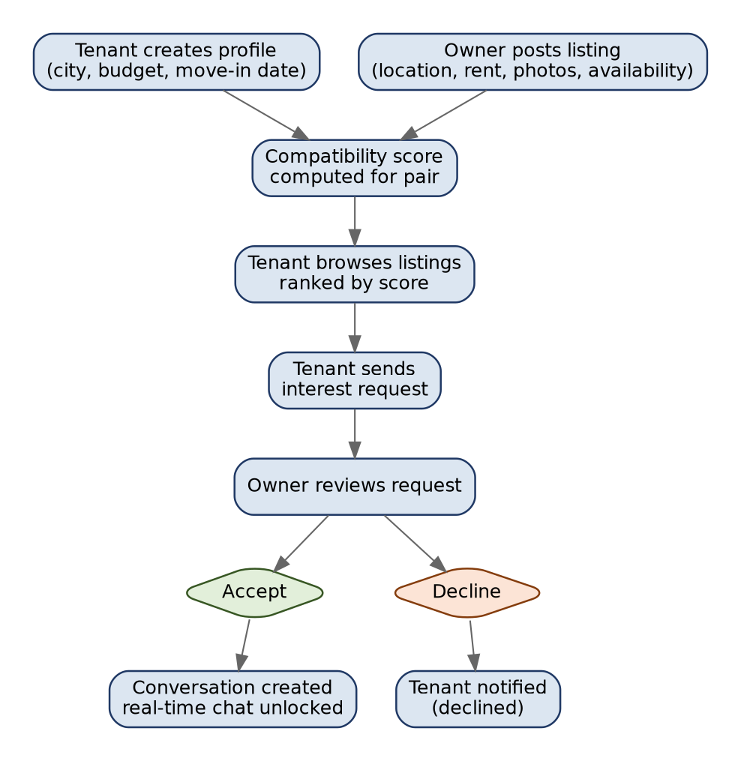
Figure 2 — Tenant and owner journey from profile/listing creation to unlocked chat.

1. Compatibility Scoring Design
Compatibility is computed per tenant-listing pair, not globally. Inputs are the tenant's budget range, preferred city/locality, and desired move-in date, compared against the listing's rent, location, and availability date. The output is a score from 0 to 100 with a short explanation, e.g. "Good match — rent within budget, same locality, move-in dates align within two weeks."
Rather than recomputing on every page load, the score and explanation are persisted in MongoDB linked to the tenant profile ID and listing ID (a compatibility_scores collection). When a tenant opens the listings feed, the API reads existing scores and sorts by score descending, only triggering a new computation when a score doesn't yet exist for that pair or either side has been updated. Filled or unavailable listings are excluded from ranking regardless of score.
Factor | Signal Compared | Weight (approx.)
Budget match | Listing rent vs. tenant budget range | 35%
Location match | Listing city/locality vs. tenant preference | 30%
Rent fit | Rent distance from budget midpoint | 20%
Move-in alignment | Listing availability vs. tenant move-in date | 15%
Table 2 — Compatibility scoring factors and indicative weighting (used identically by both the LLM prompt and the rule-based fallback).

2. LLM Integration and Fallback
Scoring is initiated by sending Gemini a structured payload with the tenant's preferences (budget range, city/locality, move-in date) and the listing's details (rent, location, room type, furnishing, availability date). Gemini is instructed to return only JSON in the form { "score": number, "explanation": string }.
The backend treats this response as untrusted input: it parses the JSON, verifies score is a number within 0–100 and explanation is a non-empty string, and rejects anything malformed or wrapped in extra text. If parsing fails, the request times out, or Gemini is unreachable, the system falls back to a deterministic rule-based calculator instead of failing the request.
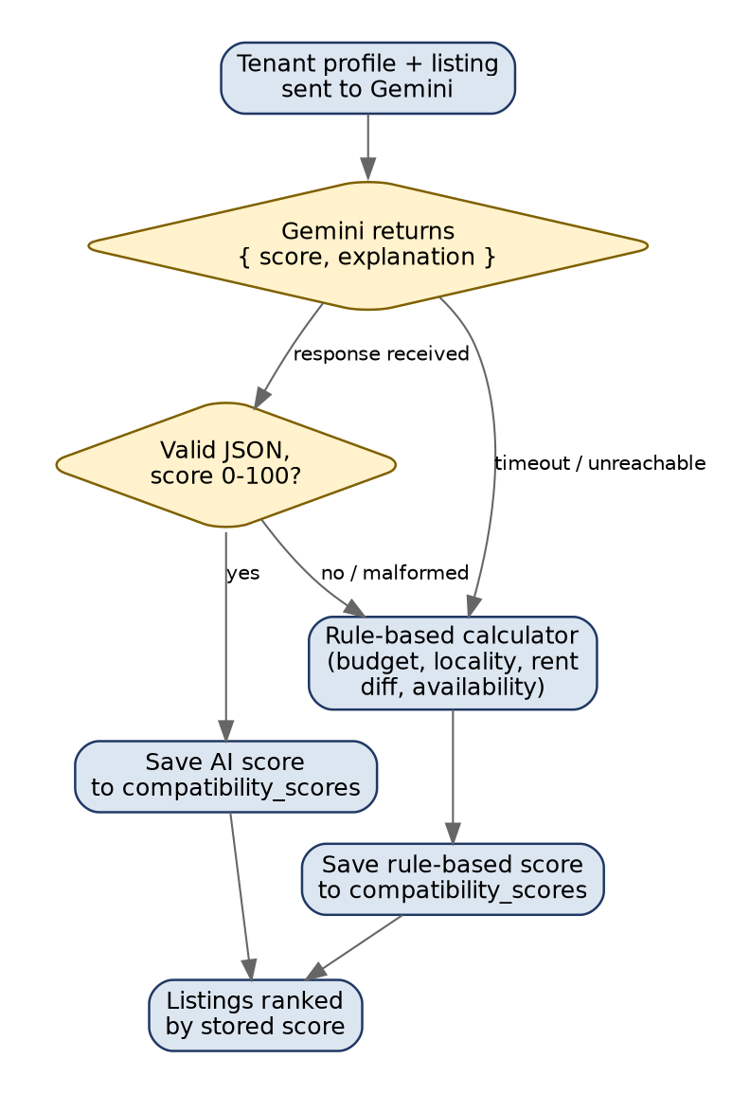
Figure 3 — Scoring request flow, including validation and fallback branch.
Aspect | Gemini (Primary) | Rule-Based (Fallback)
Trigger | Default path for every new pair | JSON invalid, timeout, or API unreachable
Output | Score + natural-language explanation | Score + templated explanation
Determinism | May vary slightly between calls | Fully deterministic, same inputs → same score
Dependency | External API availability | None — runs entirely in-process
Table 3 — Comparison between the primary LLM path and the deterministic fallback.

3. Chat Implementation
Messaging is locked until an owner explicitly accepts a tenant's interest request for a specific listing. On acceptance, the backend creates a conversation document referencing the tenant, owner, and listing; this is the only path that creates a conversation, so no one can message outside an accepted interest.
Real-time delivery uses Socket.IO. Each authenticated user joins a personal room keyed by their user ID, and the server tracks connected user IDs. When a message is sent, it is written to MongoDB first and then emitted to the recipient's room if online; if offline, the message still persists and delivers on next connection, with full history readable anytime.
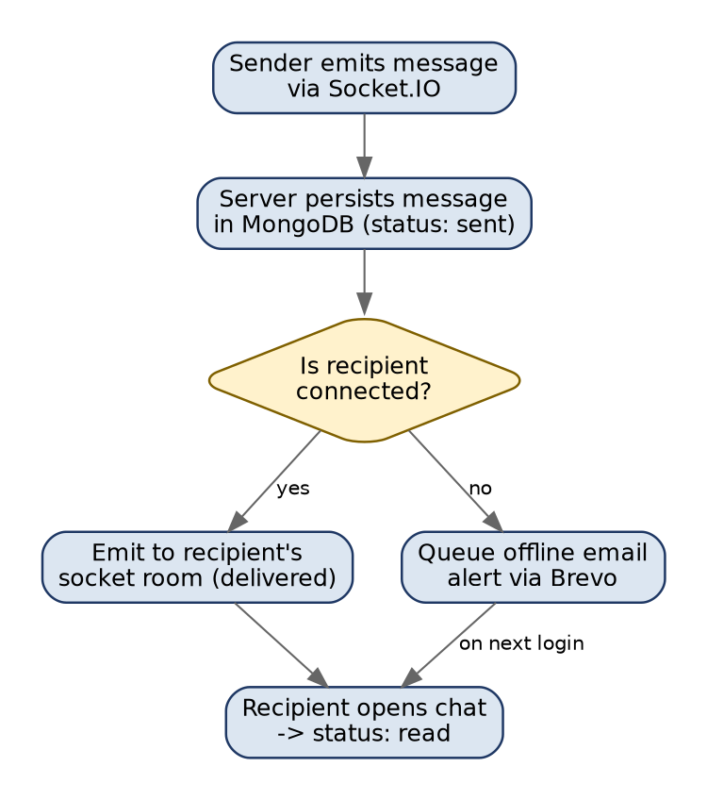
Figure 4 — Message delivery flow, covering online delivery, offline persistence, and read receipts.

4. Notification Flow
Brevo handles all transactional email. During signup, an OTP email verifies the user's address before activation. When a tenant sends an interest request on a listing with a compatibility score above a configured threshold (e.g. 80), the owner receives an email with the tenant's summary, listing details, score, and explanation — surfacing strong matches immediately rather than waiting for the owner to log in. When the owner accepts or declines, the tenant receives a corresponding email. If a chat message arrives for a user not currently connected via Socket.IO, an offline alert email is queued.
Trigger Event | Recipient | Channel
Signup / email verification | New user | OTP email (Brevo)
Interest request (score above threshold) | Owner | Email with tenant, listing, score, explanation
Owner accepts / declines request | Tenant | Status email
Chat message while recipient offline | Recipient | Offline alert email
Table 4 — Notification triggers, recipients, and delivery channel.

Cross-Cutting Concerns
- Authentication & authorization: JWT-based auth protects all non-public API routes; role-based middleware separates tenant, owner, and admin permissions at the route level.
- Media storage: room photos are uploaded to Cloudinary, with only the resulting URLs stored in MongoDB documents.
- Location input: Leaflet/OpenStreetMap on the frontend and Nominatim on the backend provide location search and reverse geocoding without a paid maps API.
- Validation & errors: express-validator checks request payloads at the route boundary, and a centralized error-handling middleware returns consistent error responses across the API.
- Admin oversight: an admin role can view and moderate users and listings and monitor overall platform activity.
Collection | Key Fields | Referenced By
users | role, email, passwordHash, verified | tenantProfiles, listings
tenantProfiles | city, budgetRange, moveInDate | compatibilityScores, interests
listings | location, rent, roomType, availabilityDate, photos | compatibilityScores, interests
compatibilityScores | tenantId, listingId, score, explanation, source | —
interests | tenantId, listingId, status (pending/accepted/declined) | conversations
conversations | tenantId, ownerId, listingId | messages
messages | conversationId, senderId, content, status | —
notifications | userId, type, payload, sentAt | —
Table 5 — Core MongoDB collections and their relationships.

Conclusion
The design keeps the AI component isolated and replaceable: it improves ranking quality when available but is never a single point of failure, since the rule-based fallback covers the same inputs. Chat, notifications, and access control are built on conventional, well-understood patterns (JWT, Socket.IO with persistence, transactional email triggers) chosen for reliability and ease of evaluation rather than novelty.

